Gender pay discrimination? Controlling for Age, TWC, and Occupation.

1. Introduction.

The data in PERSONclean.xls are part of the evidence brought in a pay discrimination case against “Company C”. Although, in analysing secondary data, there is no obligation to maintain the original focus of the data collection, we too will treat it as a question of gender discrimination. We start by establishing that there is indeed a prima facie case to be answered. We then examine and rebut different counter-arguments that the defence might have mustered, such that C’s men are older than women, have been with the company longer than women, and tend to occupy different jobs to women. While all of these are true, we show that discrimination still exists when we have controlled for each of these variables in turn.
Most of our analyses use graphical evidence about each claim, followed by more formal hypothesis-testing procedures that tell us how likely the data we observe will have arisen “by chance”. The exploratory / descriptive evidence not only guides our expectations, but also helps form our judgments about the most appropriate ways to analyse the data. We will also use 2-tailed tests throughout, first because they are more conservative, and second because it obviates the need for special case-by-case pleading.

2. Is there a case to be answered?

The left hand panel of Figure 1 compares men’s (n=201) and women’s (n=211) wages, using boxplots. At every corresponding point of the two distributions (minimum, maximum, upper and lower whiskers, Q1, Q3, and Median) men earn more than women. Furthermore, not only does the upper quartile wage for women (Q3 = £70) lie below the corresponding Q3 for men (= £87), it even lies below Q1 (=£74) for men. This means that there is a particular wage, somewhere between £70 and £74, such that at least 75% earn more than it, while at least 75% of women earn less than it!

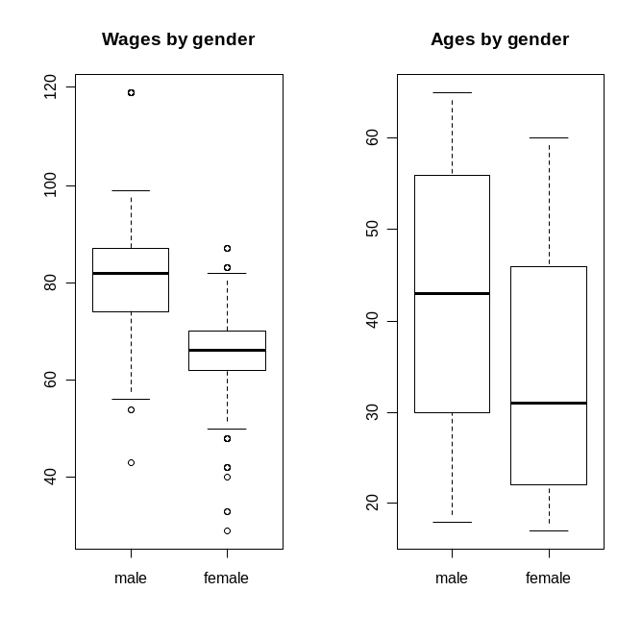
Figure 1. Comparative boxplots of male versus female wages (left) and ages (right).

The boxplots suggest no particular skew, freedom from obvious kurtosis, though with a few too many dispersed outliers than we might expect from a normal distribution. Examining the QQnorm plots, shown in Figure 2, we again see no very strong skew or kurtosis, though statistics suggest more caution. Moment skew is 0.95 for male and -0.68 for female staff. The opposite signs imply that any transformation that improves skew for men will make it worse for women, and vice versa. Excess Kurtosis is 1.28 and 2.16 for male and female staff, respectively. One further feature, not apparent from the boxplots, is that Wages are often stepped, most obviously for the 21 (male) Foremen, all with salaries of £119, which appear misleadingly as a single point in the boxplot. Overall, there is sufficient concern to use both parametric and non-parametric tests here.

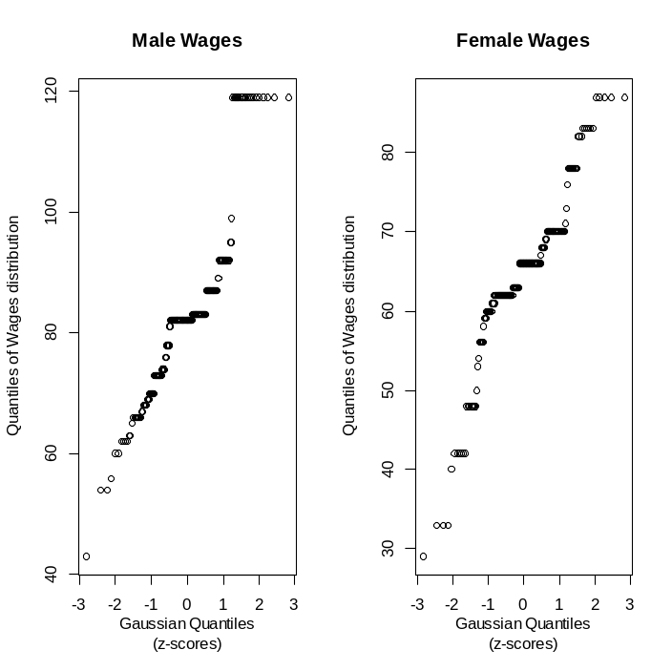
Figure 2. QQplots of empirical Wage distribution data against quantiles of the theoretical (normal) distribution.

The most general (null) hypothesis concerning gender pay discrimination is:
H₁: Men and women earn different amounts.
H₀: Men and women earn the same amount.
The mean Wage for men (£83.47) was significantly greater than for women (£64.59), t(342) = 15.14, p < 2.2 x 10⁻¹⁶. Thus we reject H₀ in favour of H₁. This rejection of H₀ is confirmed by the Wilcoxon Rank Sum test, which is distribution-free, therefore less influenced by skew and kurtosis: W = 37342, p < 2.2 x 10⁻¹⁶. In conclusion, whether looked at descriptively, using parametric tests, or using non-parametric tests, there is a prima facie case of discrimination: men do earn significantly more than women, both in a practical (men earned nearly 30% more than women) and in a statistical sense.

3. Are Wage differences really Age differences?

It might be argued that men in Company C tend to be older than women (see right hand panel of Figure 1), and indeed they are: testing the mean ages between-gender (42.58 versus 34.19 years): t(406) = 6.26, p < 10⁻⁹, and by Wilcoxon's Rank sum: W = 28647.5, p , 10⁻⁹. If older people are also paid more, then that might be the real mechanism behind gender discrimination, making discrimination more apparent than real. The relationship between age and wage is shown in Figure 3 in a scatterplot, with superimposed trend-line.
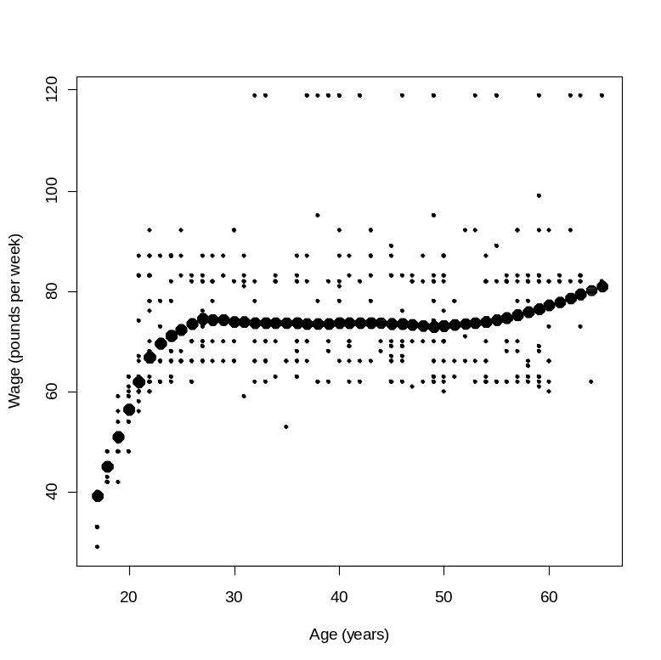

Figure 3. Scatterplot and lowess smooth (larger circles) of Age versus Wage.

Because the trend in Figure 3 is not linear, the correlation is better assessed using Spearman’s correlation coefficient rather than Pearson’s: Rho_{(n=412)} = .354, p < 10⁻¹². We therefore reject the null hypothesis that Wage is not related to Age. However, Figure 3 also shows that there are three parts to the trend-line. Up to the mid twenties there is a very marked and steep rise in Wage with Age. Then, over the next 30 years Wages are flat with Age. Finally, from mid fifties onwards there is the possibility that Wage increases slowly with Age. Assessing each part in turn: Rho_{(n=117)} = .743, p < 2.2 x 10⁻¹⁶; Rho_{(n=221)} = -.038, p > .5; and Rho_{(n=74)} = .149, p > .2. These correlations suggest that, for people older than 25, Age cannot be used to explain away gender discrimination. However, the under-26s represent a populous group (n=117, or 28% of the sample) that cannot easily be ignored. The tight correlation in this group between Age and Wage threatens to dilute the prosecution’s arguments about discrimination, by having to concede that it is only evident in certain age groups. Fortunately, there is a second way of analysing the data which is able to confirm that gender discrimination exists amongst these youngest staff too.

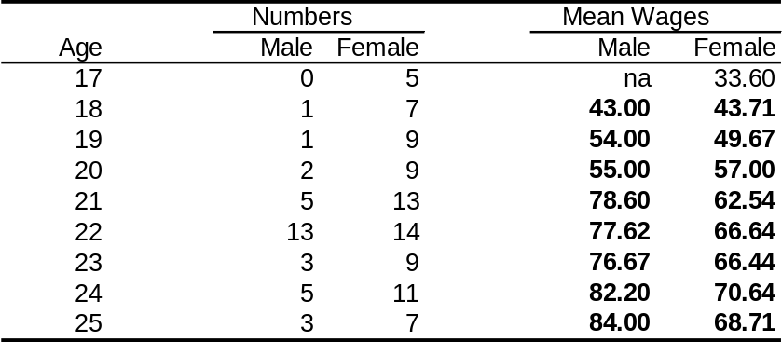

Table 1. Counts of Male and Female employees at ages 17-25, inclusive; and the mean wages at those ages.

Consider Table 1, which shows the number of Male (and Female) staff aged 17-25, and the mean wages at those ages. The means in bold are paired, row-wise, by having the same age. (We must discard the 17 year-olds as there are no males to pair with the females.) Using a paired-sample t-test, the mean wages for men are significantly greater than those for women (68.89 versus 60.67), t(7) = 3.37, p < .02. Also when tested non-parametrically, Wilcoxon paired-sample test: V=33, p < .05. We reject the null hypothesis of equality of Wages.
In conclusion, gender discrimination cannot be reduced to age differences in male versus female staff.

3. Are Wage differences really loyalty differences?

In a benign world, companies should reward staff who are loyal, i.e. stay with the company for many years. Such employees build up knowledge of organizational practice and ethos. Having loyal staff also reduces the time and money needed to recruit and train new staff. Figure 4 is the scatterplot and lowess-smooth of Wage with TWC (time with company). It shows an approximately linear trend, upwards. Statistics confirms what the eye perceives: Pearson’s correlation = .422, t(410) = 9.42, p < 2.2 x 10⁻¹⁶, and Spearman's rank correlation rho = .326, p < 10⁻¹⁰. Therefore loyal staff are paid more. Furthermore, men stay with the company longer than women (means of 10.62 versus 6.11 years), t(321) = 5.83, p < 10⁻⁷, and by Wilcoxon Rank Sum test: p < 10⁻⁶, allowing us to reject the H₀: TWC(Males) = TWC(Females). As in section 2, at face value without further investigation these results support the counter-claim that gender discrimination might be due to loyalty. In short, people who stay longer earn more; men stay longer.
To investigate this possibility, we applied the same paired-sample design used in section 2, where male and female Wages are paired at the different TWCs. There is a significant difference between Male and Female wages, t(20) = 11.01, p < 10⁻⁸, or by Wilcoxon Rank Sum: p < 10⁻⁶. That is, when TWC is implicitly held constant between Males and Females at each of 21 levels (years), there is still a significant difference between genders. TWC (loyalty) cannot re-explain the gender pay gap.
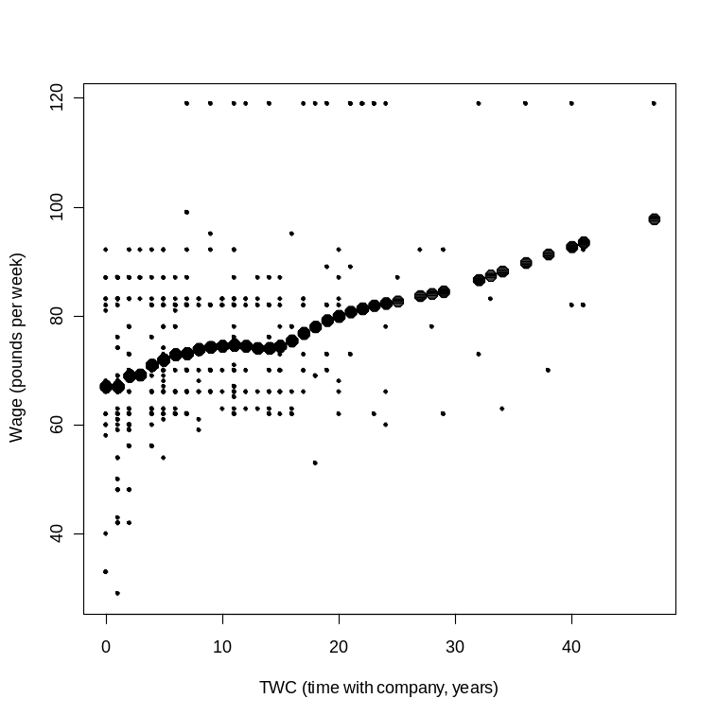
Figure 3. Scatterplot and lowess-smooth of Wage with TWC.

4. Can the jobs people do explain the gender pay gap?

Another argument goes that men and women tend to do different jobs. It's just that men do the better paid jobs. To argue for this possibility is already to admit that gender discrimination exists. But its locus is between-jobs, for instance in job (self?) selection. In this section we show that discrimination does exist within-job too, in that men earn more for doing the same job as women.

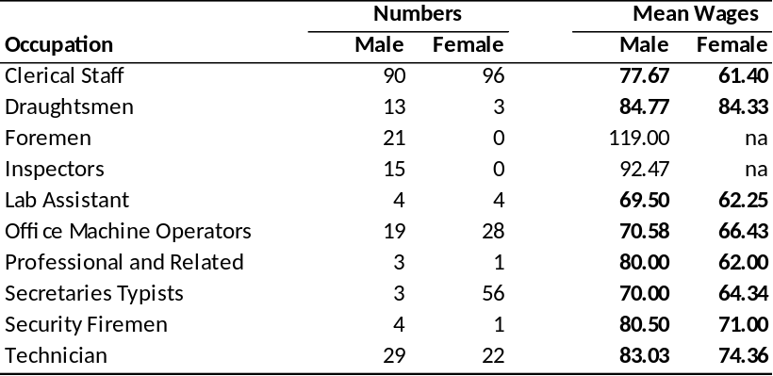

Table 2. Numbers and mean wages by Gender and Occupation.

In Table 2, since there are no female foremen or inspectors (incidentally, the two best paid jobs), we must discard them from the analysis. Doing so makes for a conservative test of pay discrimination. We construct paired sample tests of the gender mean Wages (figures in bold), first using t: t (7) = 4.18, p < .005; and also using Wilcoxon Signed Rank test, p < .01. We reject the null hypothesis of equality of means. Note in passing that in all eight occupations for which comparisons can be made, men earn more than women.

5. Conclusions.

Men are paid more than women for doing the same job. They also exclusively occupy the best paid jobs. Although age and TWC are positively related to wage, and men are older and stay with the company longer than women, a gender pay gap continues to exist when these factors are controlled for. Our conclusions are inescapable: Company C did practice pay discrimination against its female staff.

Word count: 1479, excluding footnotes, tables, figures, and their captions, section headings, and the title.
[I had to work to get it below 1500 words, and I expect you to do so too.]

Flesch Reading Ease: 49.6.
[Make sure your overall Flesch score is above 30, preferably >30 for each and every paragraph.]

Further notes:
1. The figures and tables are small enough that they do not dominate the page, yet can still be read.
2. Work to keep the footnotes together at the bottom of the page where they are referenced, rather than being split over two pages. Sometimes that means you have to locate the footnote a sentence or two from the ideal. Sometimes add a blank line, and so on. Please make the effort.
3. Try to avoid putting reference superscripts on anything that might be confusing, such as an equation.
4. I wrote one hypothesis out explicitly, the rest were abbreviated, or even implied. You can do the same (one explicit, the rest more condensed).
5. I used the "royal we". Modern usage encourages us to use "I", but I'm old-school. Take your pick.
6. Figures and Tables are numbered separately. They each have a brief caption below.
7. Axes and categories in boxplots should be labelled.
8. I have found no need for any Appendices, and I'm done in 6 pages.
9. Pages should be numbered.
10. Work your tables up outside of R. I do them in Excel. Use my kind of template if you like.
11. Do left justify your text.
12. Quote both word count and Flesch at the end of your document.
13. Make up a title that reflects what you have done. "Statistics assignment" is not good enough.
14. It helps to run your commands from an R script. When they work, you can easily copy to footnotes.
15. HOWEVER, this was just one way of writing an assignment, threading a line of argument together. Do not follow my example slavishly. For instance, I didn't use data transformations, regression, chi-squared, or 1-tailed tests, etc. They aren't here because I didn't seem to need them. Your analyses may need them, but be able to do without devices I did use. It all depends... Finally, I would like to think my report is technically quite proficient, but it's not particularly creative. Once you read the title, you should know where it's going, though not necessarily how it's going to get there. It's a bit of a me-too effort. May I encourage you to be more create than The John.

table(Gender) # how many men and women involved? par(mfrow=c(1,2)) # two separate side-by-side paired boxplots boxplot(Wage[Gender==0],Wage[Gender==1],main="Wages by gender",names=c("male","female"),varwidth=TRUE) boxplot(Age[Gender==0],Age[Gender==1],main="Ages by gender",names=c("male","female"),varwidth=TRUE)
summary(Wage[Gender==0]) summary(Wage[Gender==1])
par(mfrow=c(1,2)) qqnorm(Wage[Gender==0],main="Male Wages",xlab="Gaussian Quantiles\n(z-scores)",ylab="Quantiles of Wages distribution") qqnorm(Wage[Gender==1],main="Female Wages",xlab="Gaussian Quantiles\n(z-scores)",ylab="Quantiles of Wages distribution")
m2 = mean((Wage-mean(Wage))**2); m3 = mean((Wage-mean(Wage))**3); m4 = mean((Wage-mean(Wage))**4) Skew = m3/(m2**(3/2)); Kurtosis = (m4/(m2**2)- 3) # similarly, using Wage[Gender==0] and Wage[Gender==1].
2.2 x 10⁻¹⁶ is the smallest value to which R will compute p-values.
par(mfrow=c(1,1)) plot(Age,Wage,pch=19,cex=.5,xlab="Age (years)",ylab="Wage (pounds per week)") points(lowess(Wage~Age,f=1/3),pch=19, cex=1.5)
cor.test(Age,Wage,method="spearman") cor.test(Age[Age<=25],Wage[Age<=25],method="spearman") cor.test(Age[Age > 25 & Age < 55],Wage[Age>25 & Age < 55],method="spearman") cor.test(Age[Age >= 55],Wage[Age >= 55],method="spearman")
sum(table(Age[Age <= 25]))
table(Gender[Age <= 25], Age[Age <= 25]) # gives the counts at each age, by gender x=0; y=0 # and for the means … for (i in 18:25){ x[i-17]= mean(Wage[Gender==0 & Age == i]) y[i-17]= mean(Wage[Gender==1 & Age == i]) }
t.test(x,y,paired=TRUE); wilcox.test(x,y,paired=TRUE)
x=0;y=0 for (i in 1:50){ x[i]= mean(Wage[Gender==0 & TWC == i-1]) y[i]= mean(Wage[Gender==1 & TWC == i-1]) } t.test(x,y,paired=TRUE); wilcox.test(x,y,paired=TRUE) # NaNs won't be included in calculations
Ox = c(8,9,10,11,12,14,15,16,21,27) x=0; y=0 for (i in 1:10){ x[i] = mean(Wage[Gender == 0 & Occupation == Ox[i]]) y[i] = mean(Wage[Gender == 1 & Occupation == Ox[i]]) } t.test(x,y,paired=TRUE); wilcox.test(x,y,paired=TRUE)

